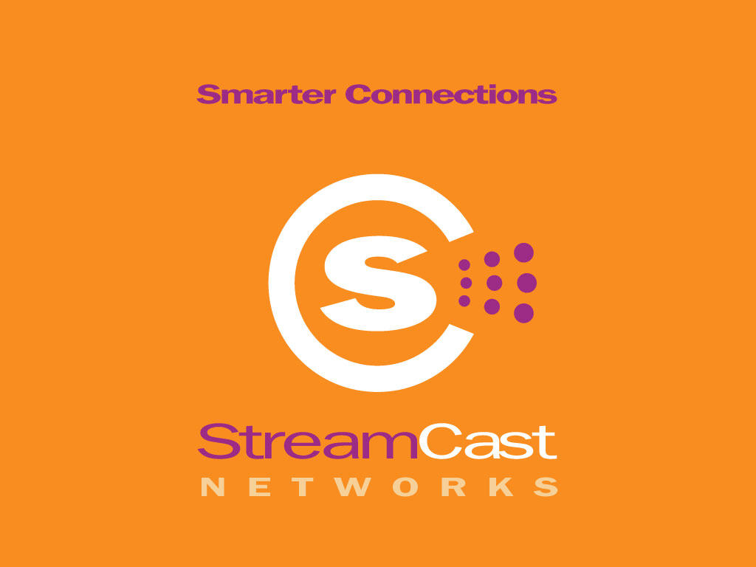

Contact: Kelly O’Neil
O’Neil Communications
408-615-8150 office
408-482-5092 cell
kelly@oneilcomm.com

STREAMCAST NETWORKS PROUDLY INTRODUCES MORPHEUS 2.0™

Morpheus 2.0 Lets Consumers Quickly Find, Download and Manage Digital Information - Available for Immediate Download on Morpheus.com

Franklin, TN.—— August 21, 2002— StreamCast Networks, Inc., makers of the most popular peer-to-peer file-sharing product, Morpheus™, today announced Morpheus 2.0™. Morpheus 2.0 is the newest version of the Morpheus product that allows millions of people to connect directly and share information.
Morpheus 2.0 delivers an out-of-this world user experience. Morpheus is the first P2P product that brings the World Wide Web and the new Internet together into one interface. This integration allows Morpheus users to search for information and communicate directly with unprecedented ease and speed. Morpheus 2.0 brings back the robust search capabilities that earned Morpheus users’ devotion as well as providing several new features and products that make downloading managing, and experiencing files better.
"Peer-to-peer communication is today’s best method of on-line communication and sharing of information and promises to be wave of the future. StreamCast Network’s Morpheus 2.0 software product provides the best user experience with its super-charged new features," said Steve Griffin, chairman and CEO of StreamCast Networks. "The release of Morpheus 2.0 is truly a proud moment for StreamCast. In addition to making substantial advancements in our core technology, we have added super-charged features to make Morpheus 2.0 our best product ever. We are thankful for the loyal Morpheus users and appreciate peer-to-peer users who stand with us in our commitment to provide outstanding, cutting edge technology."
Morpheus 2.0’s multiple technology advancements including file bundling, query routing, download swarming and metadata catalogues significantly improve the user experience. To the user, this means finding the information you want, when you want it and being able to download the information quickly and seamlessly. Here are some of the features and benefits that Morpheus 2.0 brings to Morpheus software users:

Better Access to Files: Find what you want, when you want it

With exciting new and super-charged features, Morpheus 2.0 concentrates on giving consumers access to shared files and information anytime, anywhere. Morpheus 2.0 has incorporated the following features to help users easily find what they want, when they want it:

Targeted Search Functionality
- Search by File Type including audio, documents, images, software, and video.
- Multiple Searches Simultaneously
- Target your search results

--more--

Search Power Meter
- The Search Power Meter represents the strength of your connection to the user network when using Morpheus 2.0. When search power is high, your searches will return the most results.

File Reliability Meter
- The “Reliability” column shows the reliability level for an item on the user network. The items with the highest level will usually connect and download fastest. “Reliability” takes into account the number of hosts serving the item, the hosts’ speeds, visibility limitations due to firewalls and whether or not they have available slots for you to use at the time.

Out-of-this World User Experience: Features, Functionality and New User Interface

New engine, new body. Morpheus 2.0 improves the way Morpheus users communicate and share information with one another.

New User Interface and Navigation
- Morpheus 2.0 has a completely redesigned user interface that is clean, crisp and easy-to-navigate through. StreamCast has worked hard to remodel the tabs and navigation paths to be more intuitive.

The Morpheus Media Manager™
- Provides a way for the user to manage all their media. All downloads and shared files are automatically organized in folders so that they may be easily sifted through and experienced. Folders are divided by category: documents, audio, images, video and software.

One-Stop e-Commerce Solutions: Shop and purchase items all over the Internet and get rewards and cash-back incentives

Morpheus Commerce Platform
• The Morpheus Commerce Platform™ is centered on iBill technologies that provide convenient and secure payment options. The billing platform allows consumers to make purchases directly within the Morpheus application including Morpheus Shopping Community and Fresh Gear, and with online retail partners! Additionally it allows consumers to bill monthly reoccurring charges directly.

• Morpheus Wallet™ - The consumer wallet, powered by iBill, allows consumers to make micro-payment purchases of content through Morpheus affiliates under $2.95. Consumers simply put a minimum of $5.00 into their wallet to get started.

Morpheus Tix
- Morpheus Tix™ is your one stop shop for the events you want to see. Order online, choose your seats, and the tickets are delivered to your door.

"We're confident that Morpheus 2.0 is the best peer-to-peer software application on the market today," said Darrell Smith, CTO of StreamCast Networks. "While maintaining compatibility with the open gnutella network, Morpheus 2.0 was redesigned from the ground up to include important innovations over earlier gnutella products."

For a complete feature set and product description, please download the Morpheus 2.0 fact sheet by visiting www.streamcastnetworks.com and click on press room and Morpheus 2.0 Fact Sheet.

--more--
Availability
Morpheus 2.0 is now available for download at www.morpheus.com.

The Legend of the Morpheus Brand
Morpheus™ is a brand of peer-to-peer file sharing products that has been downloaded over one hundred million times all around the world. Morpheus is a communications tool that allows users to connect together with users of the Morpheus software as well as other peer-to-peer technologies to form a user network. Morpheus users may search for and share any kind of computer file (including text, images, audio, video, and software files) with any other user of the network. Software products like Morpheus are transforming the Internet as we know it into a more connected, programmable, and searchable network with unlimited potential uses.

Morpheus Benefits

- Morpheus allows you to find files anytime, anywhere, without any waiting. The ease of use with advanced search functions such as multiple searches, keywords and descriptions along with file bundling make Morpheus a superior file-sharing software product.
- Morpheus provides users with access to a massive global user network.
- Decentralized peer-to-peer networks are the most cost effective way to deliver content because they help distribute hardware and bandwidth costs.
- Morpheus allows people to connect directly and share information. The Morpheus user network becomes richer and more fulfilling the more people use it.

About StreamCast Networks, Inc.

StreamCast Networks, Inc. created one of the most popular peer-to-peer software products in the world, Morpheus™. StreamCast Networks is a digital communications solutions provider that is revolutionizing Internet digital media distribution and communications via a unique software-driven solution, Morpheus, that enables users to communicate directly with one another more efficiently on an unprecedented scale. StreamCast Networks is backed by Timberline Venture Partners, the independently managed Northwest affiliate of Draper Fisher Jurvetson, as well as angel investors. In addition to developing and distributing one of the most popular peer-to-peer file sharing products Morpheus, StreamCast Networks, Inc. operates the MusicCity.com portal for independent artists and labels, and Morpheus.com, the distribution site of the Morpheus software product. StreamCast Networks is based in Franklin, TN with offices in Phoenix, AZ. For more information about StreamCast and its flagship product Morpheus, please visit www.streamcastnetworks.com.

###

