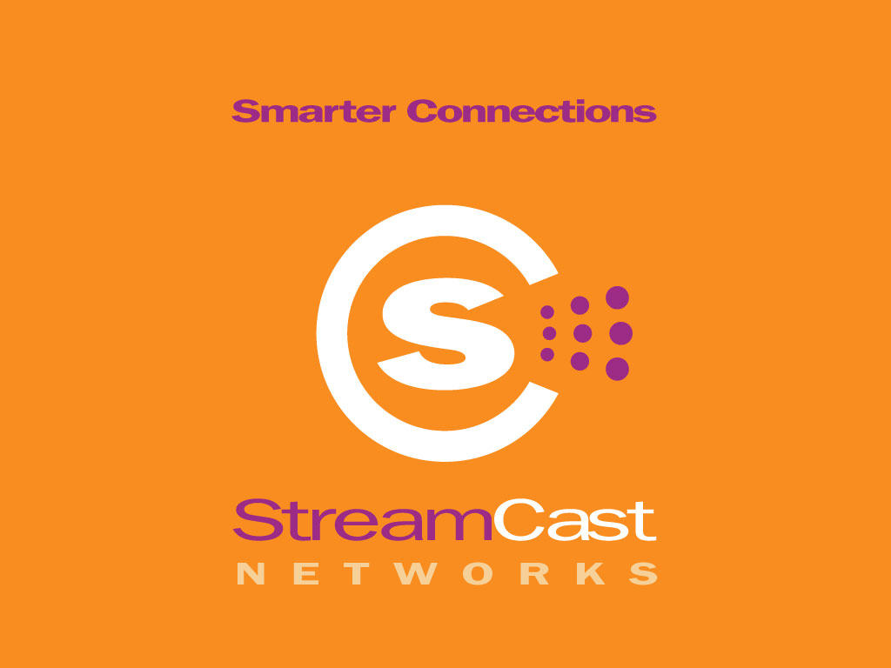

Contact: Kelly O’Neil
408-615-8150 office
408-482-5092 cell
kelly@oneilcomm.com

STREAMCAST NETWORKS ANNOUNCES AVAILABILITY OF CINTOA DIGITAL PACKAGING SOLUTION
Solution Helps Artists Control and Distribute Their Works Through MusicCity.com
Franklin, TN.—August 21, 2002— StreamCast Networks™, a peer-to-peer (P2P) technology company and the maker of Morpheus™, today announces the availability of CintoA™, an innovative digital packaging solution that enables artists to digitally package and distribute their works across the Morpheus user network.

StreamCast’s digital packaging platform, CintoA, which stands for “content into application”, allows content owners to set rules regarding the use of their material, such as designating the length of a sample or limiting the number of free listens before requiring purchase. The CintoA digital packaging solution enables the content files to be turned into applications that are distributed it across the Morpheus user network. CintoA incorporates a micro-commerce billing platform so that each artist receives compensation at a price set by the artist.

Morpheus users who purchase CintoA digitally packaged files from www.musiccity.com can find bonus information such as lyrics, pictures and biographical information included as part of the package for the digitally formatted songs they buy. MusicCity.com gives its users the power to find new music, listen to it and then buy what they want, when they want it.

“The CintoA technology is paramount in the move toward the protection of digital content over peer to peer technologies,” said Steve Griffin, chairman and chief executive officer of StreamCast Networks. “Because the CintoA Digital Package includes a commerce platform, artists get the chance to be compensated on their own terms because they have total control, they make the rules over when and how the content may be downloaded, and even set the price.”
--more--

Pricing and Availability

The CintoA solution is available today through MusicCity.com. Artists can submit their music to be packaged at mymusic@musiccity.com. Pricing for individual songs are $125 each.
Full Length Records (up to 12 songs) are $495 each.

About StreamCast Networks, Inc.
StreamCast Networks, Inc., creators of the Morpheus™, software product, is a leading global communications technology company that is revolutionizing Internet digital media distribution and communications via a unique software-driven solution, Morpheus, that enables users to communicate directly with one another more efficiently on an unprecedented scale. StreamCast Networks is backed by Timberline Venture Partners, the independently managed Northwest affiliate of Draper Fisher Jurvetson, as well as angel investors. StreamCast Networks, Inc. operates the MusicCity.com website, which distributes the Morpheus software product. StreamCast Networks is based in Franklin, TN with offices in Phoenix, AZ. For more information about StreamCast and its flagship product Morpheus, please visit www.musiccity.com.

###

