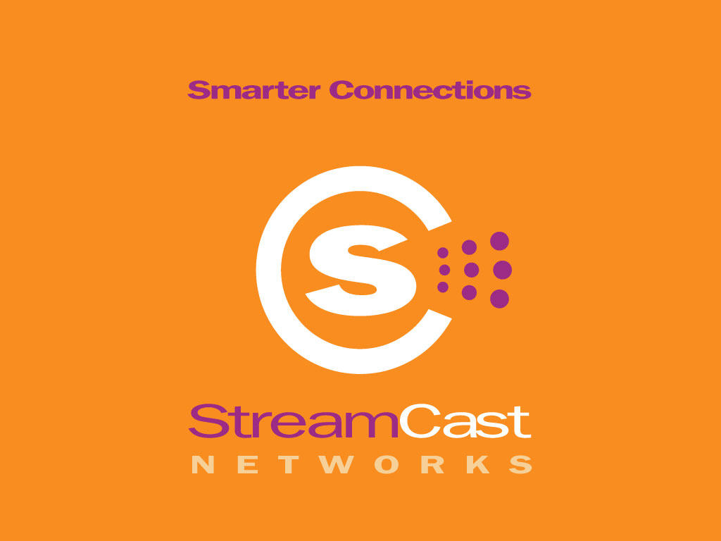

Contact: Kelly O’Neil
O’Neil Communications
408-615-8150 office
408-482-5092 cell
kelly@oneilcomm.com

EMBARGOED UNTIL ANNOUNCE DATE

STREAMCAST NETWORKS CONTINUES ITS DILLIGENT EFFORT TO EDUCATE CAPITOL HILL ON THE VALUE OF PEER-TO-PEER NETWORKS AS A COMMUNICATIONS TOOL

StreamCast Submits Testimony to September 26th Hearing and Holds Media Roundtable; Joins Computer & Communications Industry Association; Partners with Creative Commons

Franklin, TN.—— September 26, 2002 -- StreamCast Networks, Inc. provider of digital communications solutions and products, today announced that it will further its efforts to educate Capitol Hill on the benefits of Peer-to-Peer technology. This is the next important step in a long running campaign to work with industry associations and leaders to help explain the amazing benefits of Peer-to-Peer (P2P) technology as a valuable communications tool that is making societal changes.

September 26, 2002 Congressional Hearings
Steve Griffin, CEO of StreamCast Networks, will be in Washington, D.C. for the September 26th planned Congressional hearing that will discuss the future of Peer-to-Peer (P2P). It has been reported that the House Judiciary Subcommittee on Courts, The Internet, & Intellectual Property will hear from Representatives of Public Knowledge, the Recording Industry Association of America (RIAA), the Media Defender Company and a song writer.
In lieu of testifying at the hearing, StreamCast Networks is submitting written testimony on the benefits of P2P technology, meeting with members of the Committee and holding a Media Roundtable to discuss the testimony and the future of P2P technology and file sharing products like Morpheus™. Details about media roundtable are below.
In his testimony, Griffin defines Peer-to-Peer technology and communications solutions and discusses the benefits of the technology as well as its impact on society.
“The reason that I am so passionate about the Peer-to-Peer technology platform is that it not only can lead to important societal changes but also itself reflects important societal changes that have already taken place,” said Steve Griffin, CEO of StreamCast Networks. “Individuals - on their own, unaided by the communications giants - are finding their own new ways of connecting, of communicating, and of creating and controlling their own communication channels. Their will - connected and empowered - is prevailing now and Congress should not overlook them.”
In the testimony, Griffin also calls attention to the fact that consumer demand has historically spurred technological innovation and creativity that has delivered enormous benefits, both for society at large and copyright holders; however, that such innovations that have been challenged repeatedly by the entertainment industry. He notes that history proves that such technological innovations have not only made America and the world a better place, but have made the content industries and copyright holders richer too. He states that current solutions proposed by Senators Berman and Hollings do not have the consumer or the majority of content creators in mind and are neither reasonable nor workable.

--more--
“Consumers have communicated that they want to connect directly in a Peer-to-Peer environment. We at StreamCast believe that there is an array of reasonable solutions to the battle between the content industry and the technology industry over such issues as Peer-to-Peer technology and use. Rather than adopt shortsighted, nonsensical, and overreaching laws, Congress should facilitate a dialogue between the stakeholders in an effort to reach a reasonable, workable solution to these very important issues. If this fails to happen, the ordinary citizen, the consumer, is the one who will ultimately lose,” says Griffin.

Full testimony is available at www.streamcastnetworks.com in the press room.

StreamCast Networks Joins CCIA
The Computer & Communications Industry Association (CCIA) is a nonprofit membership organization for companies and senior executives from diverse sectors of the computer and communications industry. StreamCast has joined the organization to take part in the education of solutions surrounding digital content distribution and compensation for content creator’s works.
CCIA was established nearly three decades ago to represent its members’ vital interests, especially the need to promote competitive and fair open markets, open systems, and open networks. The CCIA acts as its members’ extended eyes, ears and voice in Washington, working proactively to protect and promote their interests, and to advance the key common interests of our industry.
“StreamCast is excited to be a part of the CCIA organization,” said Ellen Stroud, Government Affairs Representative of StreamCast Networks. “There are so many amazing advantages of Peer-to-Peer technology. These advantages need to be brought to the table when legislation is being drafted and voted on, and ultimately, decisions are being made on the freedom of the American public to communicate and of technology companies to innovate.”

CCIAs’ member companies range from small start-ups to global leaders that operate in all aspects of the high-tech economy. They include information technology, telecommunications and networking equipment manufacturers, as well as software, Internet, telecommunications and financial service providers, re-sellers, integrators and others. CCIA member companies employ almost one million workers and generate over $300 billion in annual revenue.

StreamCast Networks Partners with Creative Commons
The Creative Commons is a nonprofit intellectual property conservancy and has been formed to help artists set more generous terms for their works. Stanford law professor Lawrence Lessig, who is chairman of the Commons, is hoping that it will help artists and authors give some or all of their intellectual property rights to the public for free. Creative Commons and Streamcast Networks are working to develop ways of using licensing metadata to facilitate searching distributed networks.

The Creative Commons Web site (http://www.creativecommons.org/) will offer a selection of custom licenses that allow artists to indicate, in a machine- readable format, how their work can be used. The licenses set terms for copying and distribution of various types of digital material from music to photographs and can indicate whether the work can be used for commercial or noncommercial purposes.

--more--

StreamCast Networks Media Roundtable:

WHEN: Thursday, September 26, 2002
1:00 PM (EST)

WHERE: 2318 Rayburn House Office Building
Washington, DC

If you are not on or near Capitol Hill please call-in:

Conference Call
800-257-7087
Chairperson: Kelly O’Neil
Conference Title: Media Roundtable

About StreamCast Networks, Inc.
StreamCast Networks, Inc. created one of the most popular peer-to-peer software products in the world, Morpheus™. StreamCast Networks is a digital communications solutions provider that is revolutionizing Internet digital media distribution and communications via a unique software-driven solution, Morpheus, that enables users to communicate directly with one another more efficiently on an unprecedented scale. StreamCast Networks is backed by Timberline Venture Partners, the independently managed Northwest affiliate of Draper Fisher Jurvetson, as well as angel investors. In addition to developing and distributing one of the most popular peer-to-peer file sharing products Morpheus, StreamCast Networks, Inc. operates the MusicCity.com portal for independent artists and labels, and Morpheus.com, the distribution site of the Morpheus software product. StreamCast Networks is based in Franklin, TN with offices in Phoenix, AZ. For more information about StreamCast and its flagship product Morpheus, please visit www.streamcastnetworks.com.

###

