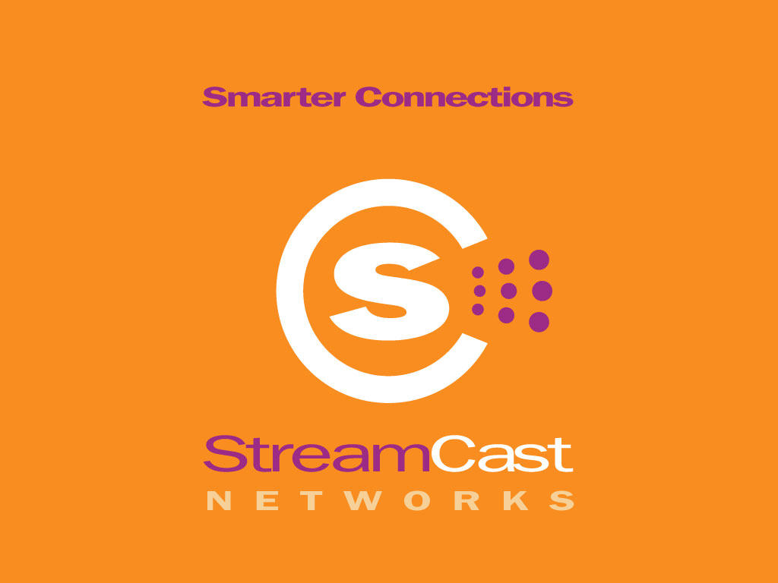

FOR IMMEDIATE RELEASE
Contact:
ellen@streamcast.ws
650.678.4629
StreamCast Networks CEO’s Statement on the Introduction of Legislation that Invites Vigilante Hackers
Hollywood Congressman Embraces Copyright Owners as Long Arm of the Law
. . . . . . . . . . . . . . . . . . . . . . . . . . . . . . . . . . . . . . . . . . . . . . . . . . . .
Franklin, TN., July 25, 2002 -- StreamCast Networks, provider of digital communications solutions and products such as Morpheus™, today released a statement by CEO Steve Griffin in opposition to legislation by Congressmen Howard L. Berman, (D-CA) and Howard Coble (R-NC) that will permit copyright holders to hack into peer-to-peer networks and directly attack consumers’ computers.
Congressman Berman's bill creates immunity for groups like the Motion Picture Association of America (MPAA) and the Recording Industry Association of America (RIAA) to shield its members from criminal and civil liability for actions taken to “disable, interfere with, block, divert, or otherwise impair” any infringing data on another computer, as long as they have a “reasonable basis”, to believe that copyright infringement has occurred. Copyright owners will only need to give notice to the Justice Department of the “specific technologies the copyright owner intends to use”. However, the bill does not permit these technologies to be disclosed to the very persons they will attack, the public.
******

“Today, cyber warfare was declared by the Hollywood Congressman, which many predict will effectively shut down peer-to-peer (P2P) networking by allowing copyright owners to employ what Congressman Berman previously referred to as ‘technological self-help measures’ such as interdiction, redirection, decoys, spoofing and file-blocking. It not only gives copyright owners a ‘safe harbor’ from current state and federal laws, but also essentially makes copyright owners the proverbial ‘long arm of the law’ to self-enforce rules set by the government without meaningful remedy for abuse of the rights requested in the legislation. There have been media reports that record labels have already launched an aggressive assault on file-sharing networks by flooding on-line swapping services with spoofed (a.k.a. decoy) files such as bogus copies of popular songs. The companies which are believed to have created this new generation of self-help technological measures refuse to talk about their clients and Hollywood refuses to disclose the specific tools they wish to employ. Yet, it appears that Hollywood recognizes that such tactics may run afoul of state and federal laws, leading to Congressman Berman introducing legislation that could legalize their illegal actions.

The attitude of consumers toward on-line entertainment and the sharing of information is clear. They want available commercial content, they want to create content to share and they want a broadband connection. The reason that I am so passionate about the technology platform of peer-to-peer (P2P) is that this ‘New Internet’ is capable of world-wide societal change. In this new world consumers are not merely receivers of information, they are also senders.

There is little debate that consumers around the world represent an incredible opportunity to release creative expression. Decentralized P2P offers the most cost effective and efficient distribution that exists today. By leveraging millions of consumers’ computers and their distributed bandwidth, enormous cost of goods savings can be realized. When consumers launch the Morpheus P2P software, they join and help create a self-organizing, self-sustaining network of users around the world. The more users that join the network and share content, the richer the experience is for everyone.

A true P2P software product, like Morpheus, allows consumers to connect directly with each other and to exchange any type of information – anything – recipes, family photographs, a poem from a budding poet, commentary on public issues, anything. Once consumers have downloaded the Morpheus software they choose what electronic information that they want to make available to people around the world. In short, Morpheus allows consumers to directly connect to each other like the Internet was intended to be. In fact, many call decentralized P2P “the New Internet”. It is a new gateway or alternative to the World Wide Web. We are passionate about incorporating different tools that empower consumers to communicate and exchange information while protecting the creators’ content.

At StreamCast we believe that P2P is an important technology that not only can lead to important societal changes but itself reflects important societal changes that have already taken place. Individuals - on their own, unaided by the communications giants - are finding their own new ways of connecting, of communicating, and of creating and controlling their own communication channels. Their will - connected and empowered - is prevailing now and Congress should not overlook them.

StreamCast Networks continues to urge and foster communication with the four stakeholders in this issue - content holders, content creators, technology companies and most importantly consumers - to come together and find a solution that brings to bear the interests of all parties. Rather than adopt a nonsensical law as proposed by the Hollywood Congressman, Congress should instead facilitate a dialogue among the stakeholders in an effort to create a reasonable, workable solution to this very important issue.

We encourage individuals to write (http://www.house.gov/writerep/) their Member of Congress and express their concern about the yet to be named Berman legislation, as it is anti-consumer and anti-innovation and invites unchecked hacking into and impairment of peer-to-peer networks.”
******
About StreamCast Networks, Inc.
StreamCast Networks, Inc., creators of the Morpheus software product, is a digital communications solutions provider that is revolutionizing Internet digital media distribution and communications via a unique software-driven solution that enables users to communicate directly with one another more efficiently on an unprecedented scale. StreamCast Networks is backed by Timberline Venture Partners, the independently managed Northwest affiliate of Draper Fisher Jurvetson, as well as angel investors. StreamCast Networks, Inc. operates the MusicCity.com website, which distributes the Morpheus software product. StreamCast Networks is based in Franklin, TN with offices in Phoenix, AZ. For more information about StreamCast and its flagship product Morpheus, please visit www.streamcastnetworks.com.

